Chapter-Understanding Quadrilateral/Class: 8/CASE STUDY
Theme: Fire Cracker-Burning fire cracker is symbol of joy and happiness in many countries. It mainly burns during new year and special occasion of the different countries. During new year Amit and his family went to an orphanage to share happiness with other needy children. They distributed sweets and crackers to them. Shape of one cracker is shown below.While burning, a question came to the mind of a child. Help him to find the answers
- What is the shape of the cracker?
- After lightning the cracker at what angle with respect to the edge sparks ejected if the shape is regular.
- What is the interior angle of the cracker?
- What is the total angle covered by cracker in ten rotation.
Theme: Mt Everest-‘Krushnaa Patil is the youngest woman who successfully climbed Mount Everest. She achieved this at the age of 19,in 2009. At a very early age she was passionate about mountain climbing. During her childhood most of her vacations were on Himalaya’. By reading this article a child of class 8 also get passionate about mountaineering and search different instruments required for that. He made a ladder of given shape. The distance between two consecutive rungs is 50cm on both sides.
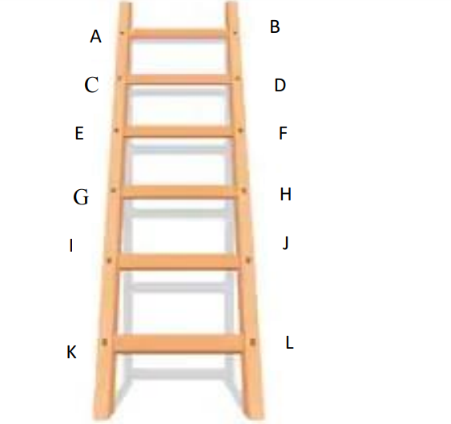

Based on the above information , answer the following questions
- What shape is formed by two consecutive rungs with adjacent side?
- If ∠𝐵𝐴𝐶 = 110°, 𝑓𝑖𝑛𝑑 ∠𝐴𝐶D?
- What should be the measures of ∠𝐴𝐵𝐷 & ∠𝐵𝐷𝐶?

